**SKILL LEARNT: PL/SQL PROGRAMMING (WEEK 2)**

**EXERCISE 1: CONTROL STRUCTURES**

1. **SCENARIO 1**

We have to create two table Customers table and Loans table:

**TABLE CREATION:**

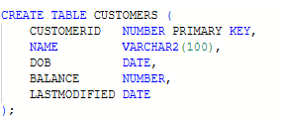

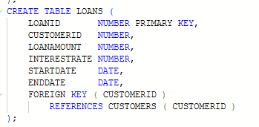

**INSERTING VALUES INTO TABLES:**

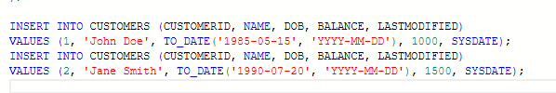



**PL/SQL BLOCK OF CODE:**

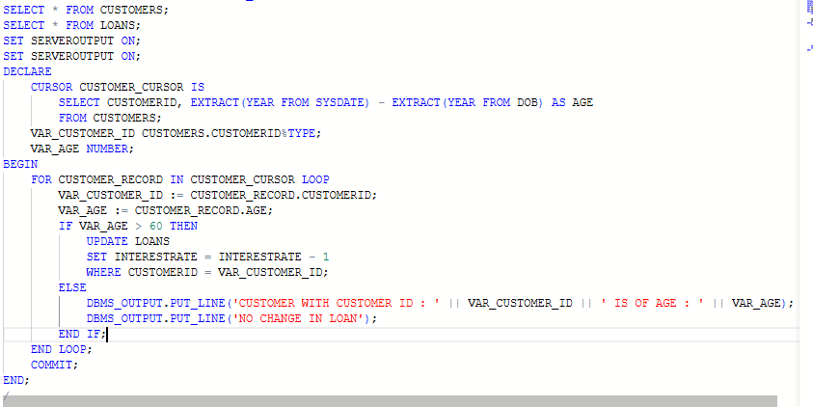

**OUTPUT:**

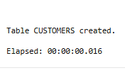

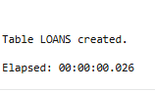

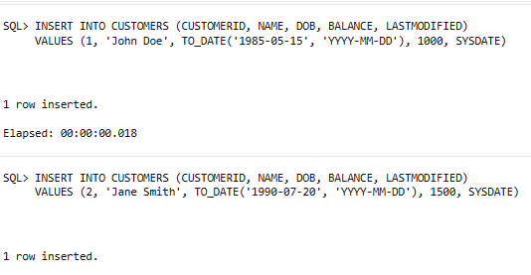

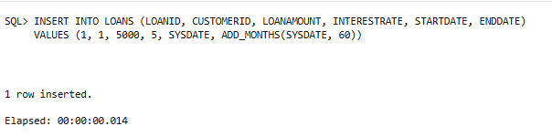

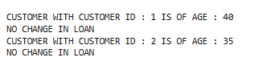

1. **SCENARIO 2**

**TABLE CREATION:**

We created two table Customers table and Accounts Table

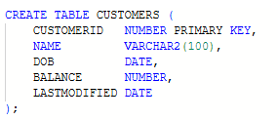

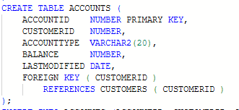

**INSERTING VALUES INTO TABLES:**

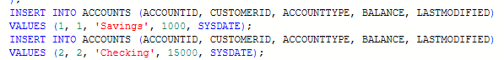



**PL/SQL BLOCK OF CODE:**

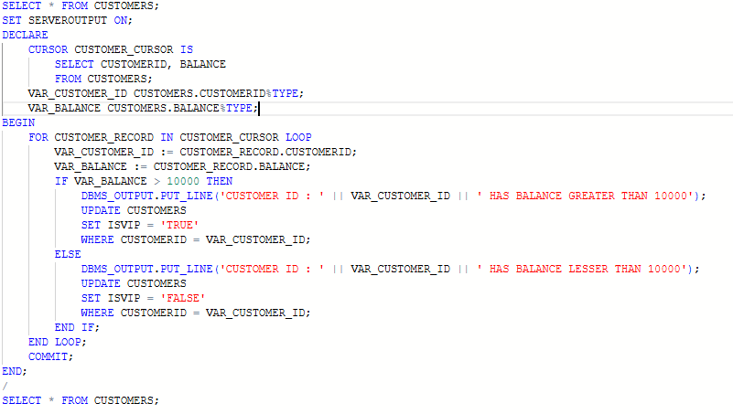

**OUTPUT:**

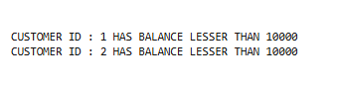

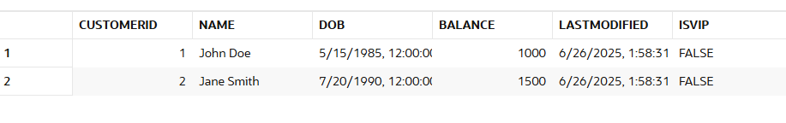

1. **SCENARIO 3**

**TABLE CREATION:**

The same Customers table and Loans table is used





**INSERTING VALUES INTO TABLES:**

The same set of values are inserted again





**PL/SQL BLOCK OF CODE**

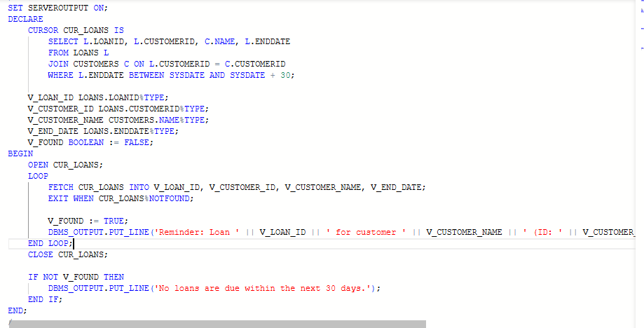

**OUTPUT:**

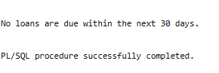

**EXERCISE 3: STORED PROCEDURES**

1. **SCENARIO 1**

**TABLE CREATION:**

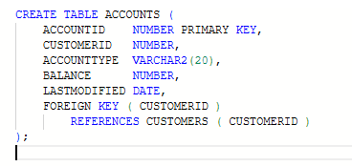

**INSERTING VALUES INTO TABLE:**

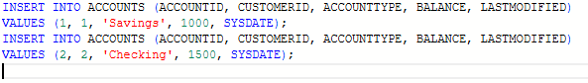

**PL/SQL BLOCK OF CODE:**

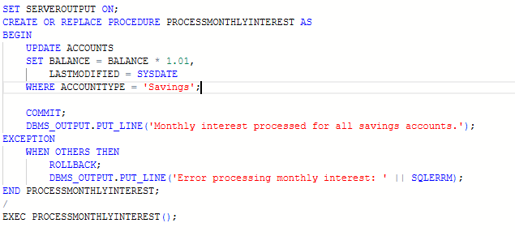

**OUTPUT:**

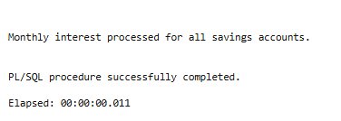

1. **SCENARIO 2**

**TABLE CREATION:**

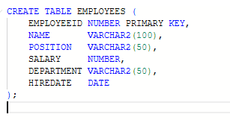

**INSERTING VALUES INTO TABLE:**

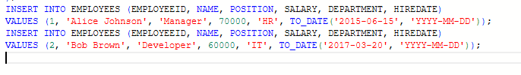

**PL/SQL BLOCK OF CODE:**

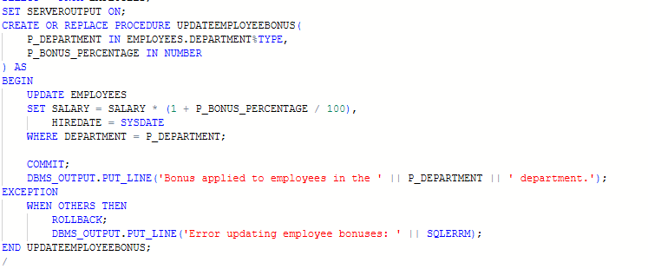

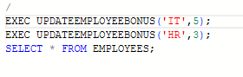

**OUTPUT:**

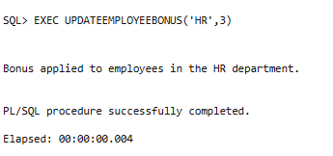

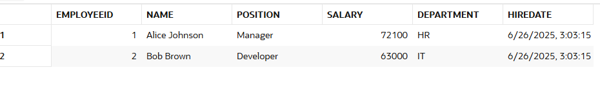

1. **SCENARIO 3**

**TABLE CREATION:**

The same Accounts table will be used.



**INSERTING VALUES INTO TABLE:**

The same values are inserted to the Accounts table



**PL/SQL BLOCK OF CODE:**

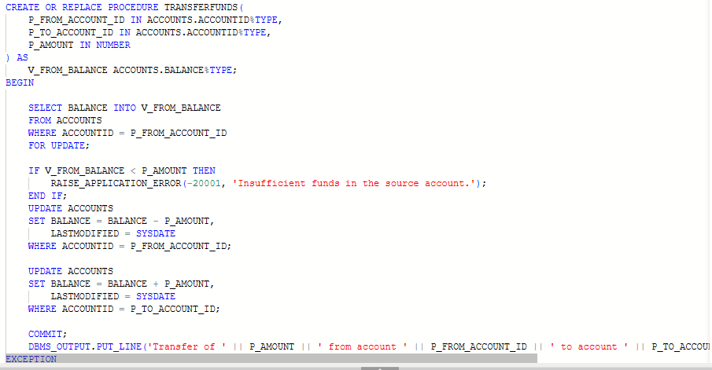

**CONTINUED…..**

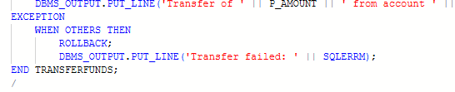

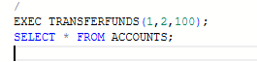

**OUTPUT:**

